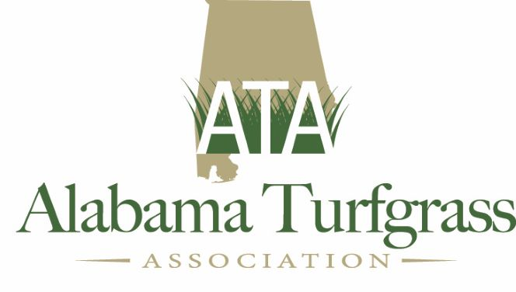
Alabama Turfgrass Association
2023 Slate of Officers and Board of Directors

Executive Committee:
President
Ben Williams
Cypress Tree GC

Vice President
David White
University of Alabama at Birmingham

Secretary/Treasurer
Patrick Pierce
Grand National Golf Club

Past President
Ben Anderson
Arrowhead Country Club

Board of Directors:

Golf – Needs to be Filled

Industry
Chris Moras
Ground Works Distribution (through 2022)

2023- Glenn Lucas
TurFace

Institution: Drew Charcandy,
University of Alabama (through 2023)

Darrell Arnold (2023)
Heritage Lawn Care

Park & Recreation - Jonathan Gruber (2023)

Sod – (2023)
Hunter McBrayer, Alfa

At Large

Jennifer Morgan – City of Gulf Shores (2023)

Travis Stein (2023)
Regal

Mark Irwin (2023)
City of Foley

Ex Officio/Education Advisors

David Han, Ph.D.
Auburn University

Jim Jacobi, Ph.D.
Alabama Cooperative Extension System

